Armenia hosted the Coordinating Council on Plant Quarantine of CIS countries

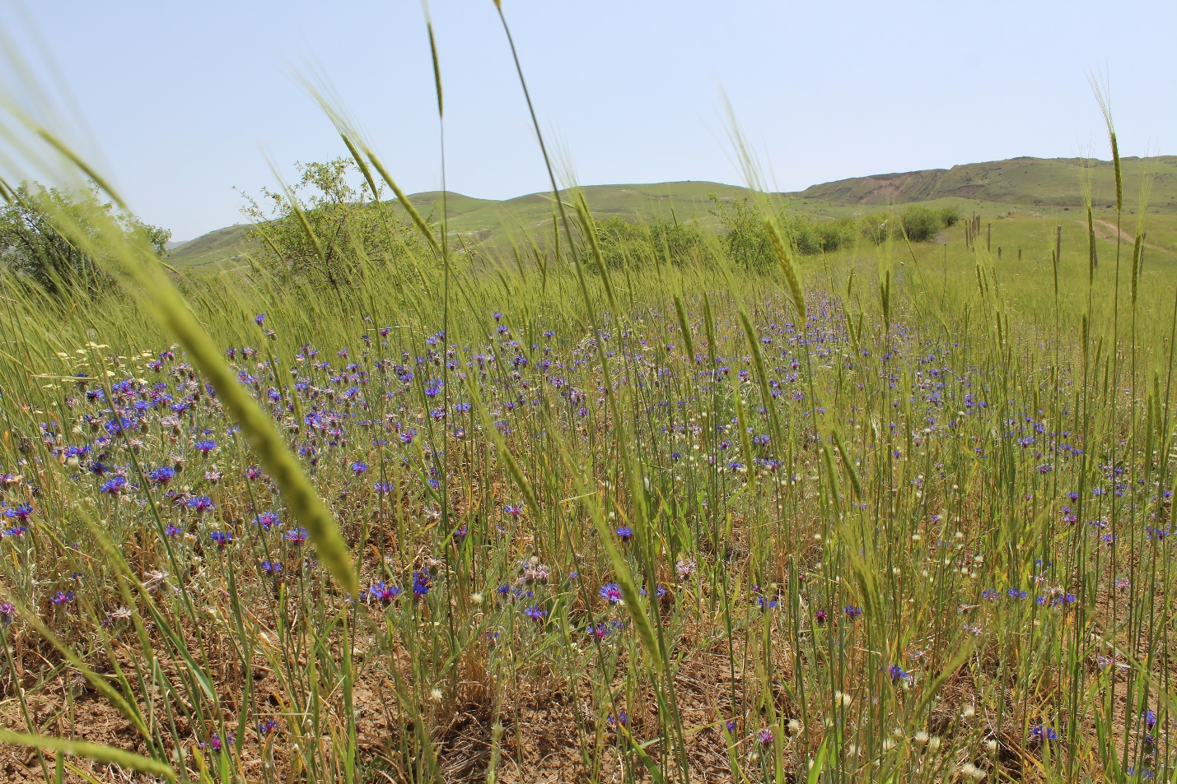Landscape in Armenia. Photo: ©FAO/Ani Grigoryan

28-29 October 2021, Yerevan, Armenia – For the second time already, the Commonwealth of Independent States (CIS) Plant Quarantine Coordinating Council meeting was hosted by Armenia, this time with support of the Food and Agriculture Organization of the UN (FAO).

Heads of phytosanitary services of the CIS member states, representatives of the CIS Executive Committee, the Eurasian Economic Union, the Federal Customs Service and the Plant Quarantine Research Center of the Russian Federation, as well as representatives from FAO took part in the two-day session.

During the recent years, to ensure food security in many countries of the world, including Armenia, agriculture has been in the focus of special attention, and in that regard, phytosanitary control is the most important tool to ensure plant safety and agricultural development. To this end, participants presented phytosanitary policies pursued by their countries, including quarantine-phytosanitary conditions, infected areas, existing harmful organisms, prevalence, and control measures.

Welcoming the guests, Georgy Avetisyan, the head of the Food Safety Inspection Body of Armenia presented the tasks to be implemented related to phytosanitary control in Armenia.

"Phytosanitary is the main guarantee to prevent the entry of quarantine organisms into the country, to detect, isolate and destroy them, and, of course, to get a healthy, rich harvest. Every year in the world, plant pests increase, new species appear. Our country is no exception, so I think that in all areas of food safety, including phytosanitary, we should be guided by scientific principles of risk assessment," said Avetisyan.

Piotr Wlodarczyk, FAO Agriculture Specialist introduced international examples in the field of phytosanitary as well as the plant pests control measures.

During the two-day event, the possibilities of simplifying the import and export procedures of plant products to/from CIS countries, associated problems and their possible solutions, as well as the best experience of cooperation were covered.

