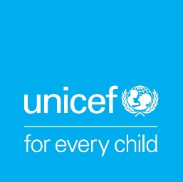

Armenia Launches Generation Unlimited (GenU) Youth Challenge
50 young people join GenU Bootcamp online to compete at social entrepreneurship

YEREVAN, May 18, 2020 – UNICEF, UNDP, joined by UWC Dilijan and Ayb Education Foundation, launched Armenia’s first Generation Unlimited (GenU) competition today in an online Bootcamp, joined by 12 teams (50 young people), from Shirak, Vayots Dzor, Kotayk, Tavush, Gegharkunik, and Yerevan.

GenU is a global multi-sector partnership to meet the urgent need for expanded education, training and employment opportunities for young people, aged 10 to 24, on an unprecedented scale. The competition helps create public-private partnerships – globally and in countries – to co-create and support investment opportunities, programs, and innovations on a large scale, and to help young women and men become productive in life.

"We are going to co-design and co-create with young people. Adolescent girls and boys as well as youth can see the world with fresh eyes and imagine solutions that are needed to get the world back on track, we just need to give them opportunities to work together and think creatively," said Tanja Radocaj, UNICEF Representative in Armenia.

50 participants of the online Bootcamp were selected from 60 teams who applied in mid-February with initial ideas about social entrepreneurship and community projects. The ideas are many, spanning from smart agriculture to innovative volunteerism for the common good, creative industries, arts, fashion, video production, and many more. From May 18 to May 24, the Bootcamp will offer them a series of online meetings and mentoring from seasoned specialists in social entrepreneurship, business, and startups who will help them refine their ideas and turn them into projects.

“Through GenU we hope to inspire Armenia’s youth to generate new ideas and bring them to life, thus contributing to the creation of new opportunities, entrepreneurial initiatives, and workplaces in their communities,” said Dmitry Mariyasin, UNDP Resident Representative in Armenia.

On May 24, the teams will present their projects to the panel of judges, and the top five will receive a US$ 1000 grant to bring their ideas to life during the second half of 2020. In the second phase of the competition, the two most promising ideas from Armenia will be presented at the international stage in the USA, competing with teams from other countries for a chance to win up to US$ 20,000 and participate in the Idea Incubator Program.

