UNHCR Armenia Emergency Humanitarian Assistance
for refugees, people in refugee-like situation, asylum seekers and stateless persons
(in the frame of COVID-19 response)
28 May 2020
At a glance
- In total, 507 households that complied with UNHCR-developed eligibility criteria received emergency monetary assistance.
- The overall budget for extra one-time cash assistance related to COVID-19 comprised around USD 125,000.
- Personal data on beneficiaries were maintained in strict compliance with UNHCR data protection policy.
Objective and scope of assistance
To complement the Government’s efforts in mitigating the social and economic impact of COVID-19 pandemic and the state of emergency on the population, UNHCR initiated emergency humanitarian assistance in the form of a one-off cash assistance to vulnerable displaced households helping them cover their basic needs: food, hygienic items and other critical needs. The aim was to help the vulnerable beneficiaries who fell outside of the state assistance schemes to cope with adverse social and economic impact of COVID-19 on their livelihoods.
From 15 April to 22 May 2020, UNHCR’s partner - Mission Armenia NGO - made bank transfers to accounts of adult members of displaced households.
Eligibility
For the selection, households with (i) refugees, (ii) asylum-seekers, (iii) persons forcibly displaced from Syria or (iv) stateless persons were considered. Additional vulnerability criteria included the following: single parent or caregiver, elderly person, woman or child at risk, individual with disability or serious medical condition, without access to state social protection scheme or other known assistance provided by partner entities.
Acknowledging that the needs of persons may have exacerbated due to the outbreak of COVID-19, UNHCR expanded the emergency assistance to a limited number of households with no prior vulnerabilities, other than those described above.
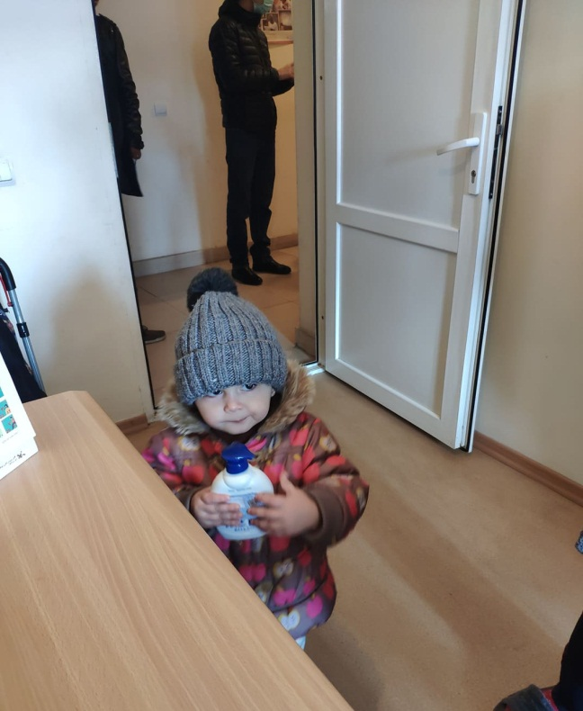 | For more information,  please contact us at:  UNHCR Armenia  14, Petros Adamyan Str., Yerevan  E-mail: armye@unhcr.org  Tel.: +374 91 415 387;  +374 10 54 59 35
Photo by Mission Armenia NGO. A refugee child helping her
mom receive humanitarian assistance at the Integration
House of Migration Service, April 2020.

