The 1961 Statelessness Convention: 60 years of promoting and protecting the right to a nationality
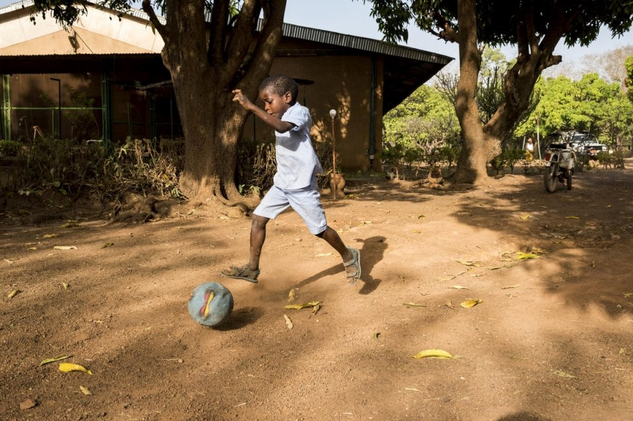
Formerly stateless foundling Marc Eric is now a citizen of Côte d’Ivoire, after a judicial ruling confirmed his right to nationality. © UNHCRMark Henley

Ensuring the right to a nationality and eradicating statelessness is achievable and more pressing than ever, UNHCR, the UN Refugee Agency, stressed today, as the international community marks the 60th anniversary of the adoption of the 1961 UN Convention on the Reduction of Statelessness.

“New global challenges, such as COVID-19 and the effects of climate change, on top of persistent ones like rising forced displacement, showcase just how critical the right to a nationality is. Everyone needs to be counted and be visible in the eyes of their country and government, and included into responses,” said Filippo Grandi, UN High Commissioner for Refugees.

“Having a nationality – and the protection of a government that nationality affords – can make a life-saving difference, even more so in times of crisis, whether it’s vaccination, evacuation or providing a social safety net that is needed,” Grandi added.

Stateless people can fall between the cracks in conflict and displacement situations because they lack the protection of any government, they don’t have proof of their legal identity, or both. They also risk being excluded from accessing COVID-19 vaccinations as countries implement plans to tackle the pandemic. Similarly, stateless communities are unlikely to be included in socio-economic relief packages intended to lessen the pandemic’s impact on people’s livelihoods. Moreover, as climate change worsens, stateless people risk being excluded from government efforts to mitigate the effects of extreme weather events.

More broadly, being stateless can mean having no access to education, medical care or legal employment. Statelessness can hinder freedom of movement, the ability to buy property, vote, open a bank account or even to get married. Globally, 4.2 million people are known to be stateless. However, the true number of persons not recognized as citizens by any country is likely to be much higher, given gaps in data collection.

The 1961 Convention is the key international treaty designed to prevent and reduce statelessness. If applied by all States, it would help to ensure that no child is born without a nationality – ultimately supporting the eradication of statelessness over time.

As of the end of August 2021, 77 States have joined the 1961 Convention, with accessions accelerating in the last decade. Since 2010, 40 States have formalized their commitment to reduce statelessness by becoming parties, most recently Iceland and Togo.

In the same period, more than 800,000 stateless people are known to have had their nationality confirmed and statelessness resolved.

“In this anniversary year, UNHCR is urging all States that have not already done so to join the 1961 Convention on the Reduction of Statelessness, to incorporate the safeguards of the Convention into their nationality laws, and to guarantee every person’s right to a nationality,” Grandi said.

Accession to the 1961 Convention is one of the 10 actions of the Global Action Plan to End Statelessness. The Plan provides a framework for States to achieve the goals of the #IBelong Campaign, which was launched by UNHCR and partners in 2014 to end statelessness within 10 years.

END

