Armenia works towards improving its legal framework to reverse forest degradation

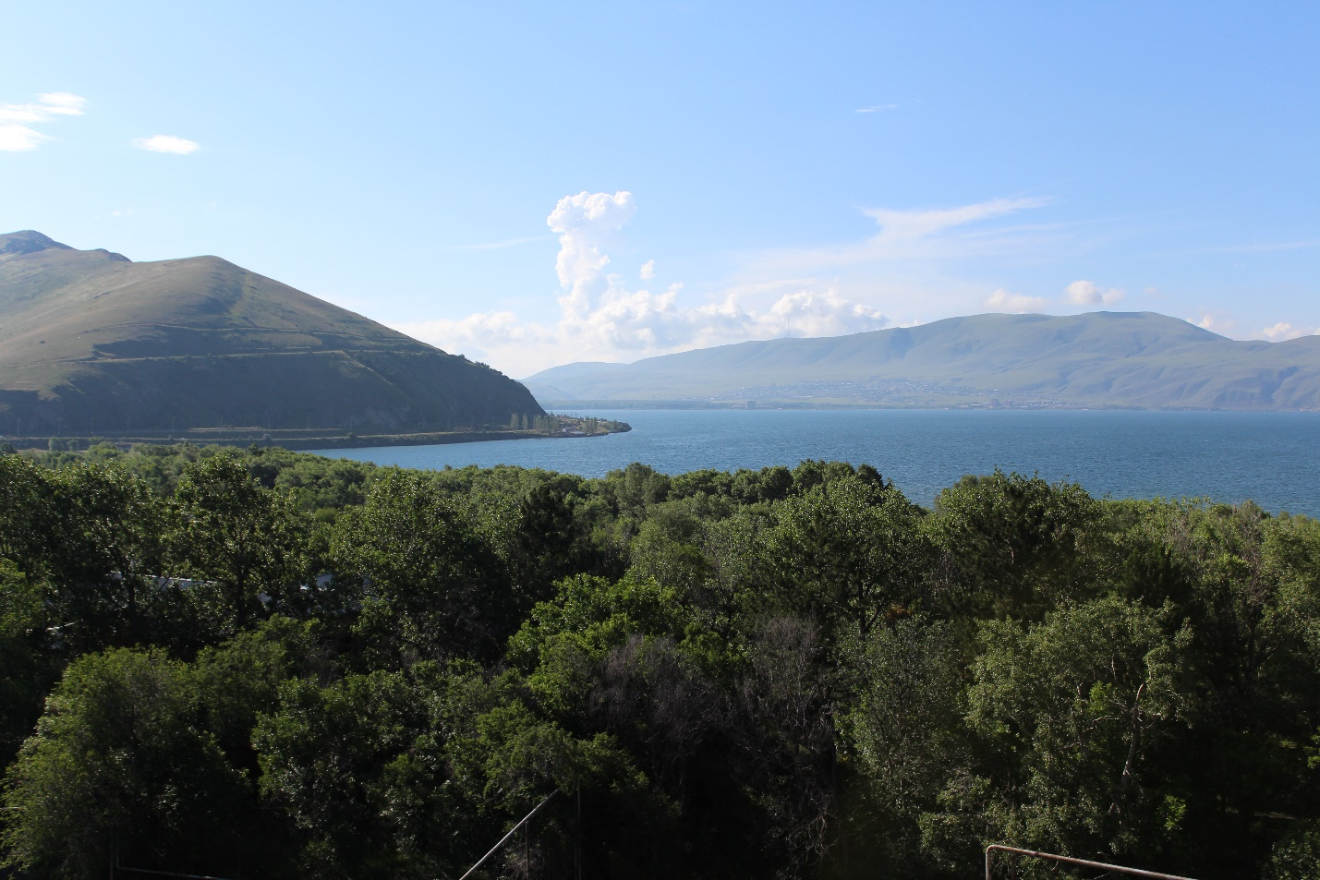 Landscape in Gegharkunik marz, lake Sevan, Armenia. Photo: ©FAO/Ani Grigoryan

13 August 2020, Yerevan, Armenia – At a consultation meeting today, experts, government representatives, and other interested parties discussed and reviewed the first draft of Armenia’s new National Forest Programme. The development of the document was supported by an FAO project, upon request of the Government of Armenia, that aims to increase national forest cover to over 20.1 percent by 2050 and, at the same time, improve the condition of existing forests through the establishment of an enabling policy framework.
“The new National Forest Programme will be the cornerstone of Armenia’s efforts to reverse forest degradation and meet the international commitments of the country on increasing forest cover,” said Norbert Winkler-Ráthonyi, FAO forestry officer.
In the past decades, a number of policy documents have been developed with support from international organizations that concern forests and forest management aimed at reversing the trend of forest degradation and overexploitation of forests in Armenia. These documents include the national forest policy and strategy (2004), the national forest programme (2005); and several by-laws and related documents.
To continue the work towards this goal, the Ministry of Environment requested technical assistance from FAO to address the urgent need for a renewed national forest policy and strategy, as well as for a revision of the National Forest Programme.
The project contributes to develop activities for sustainable forest management in Armenia in line with government priorities, as well as FAO’s regional and global objectives, and with the Sustainable Development Goals. The main partner is the Government of the Republic of Armenia, specifically the Ministry of Environment and public bodies in charge of forestry and related disciplines, and also non-governmental organizations involved in environmental protection and natural resource management.

