**Scholarships on offer for post-graduate studies of agriculture in Hungary**

Deadline for applications for the 2021–22 programme: 28 February 2021

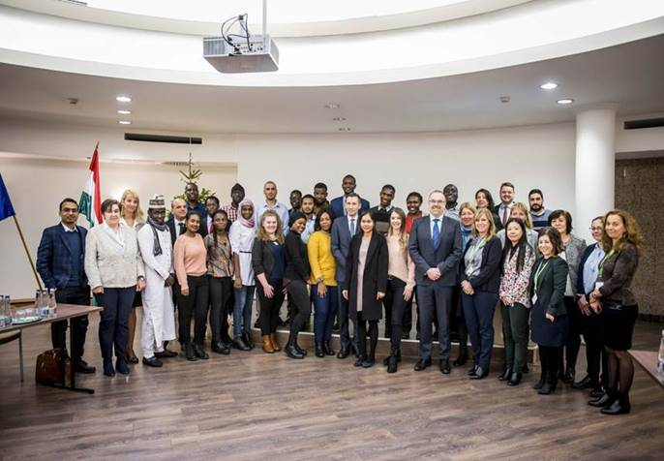

*Photo: ©Hungarian Ministry of Agriculture*

***14 January 2021, Budapest, Hungary –*** Applications are now being accepted by the [FAO / Hungarian Government Scholarship Programme](http://www.fao.org/europe/news/detail-news/en/c/1369300/?utm_source=fao%20press%20release&utm_medium=email&utm_campaign=fao). The two-year scholarship finances post-graduate studies in agriculture-related disciplines for promising students from developing and middle-income countries.

Now in its thirteenth consecutive year, the Hungary-sponsored FAO scholarship programme offers young professionals the opportunity to widen and deepen their knowledge. Those accepted to the programme will pursue studies in agricultural water management engineering, plant protection, or crop production at the renowned Hungarian Szent István University.

The scholarship covers application and tuition fees, basic books, dormitory accommodation, subsistence costs, and health insurance.

[Deadline for submitting applications](http://www.fao.org/europe/news/detail-news/en/c/1369300/?utm_source=fao%20press%20release&utm_medium=email&utm_campaign=fao) is 28 February 2021, for the academic year starting in autumn 2021.

To date, over 350 students have benefitted from the FAO-Hungary scholarship. Returning to their home countries, they have better chances on the job market. They also have access to a global professional network: their fellow scholars and their professors.

Nationals of the following countries, who also reside in their countries, are eligible to apply for the programme:

Afghanistan, Albania, Algeria, Angola, Azerbaijan, Armenia, Bangladesh, Belarus, Bosnia and Herzegovina, Burkina Faso, Cambodia, Chad, Egypt, Ethiopia, Gambia, Georgia, Ghana, Jordan, Kazakhstan, Kenya, Kosovo*1*, Kyrgyzstan, Laos, Lebanon, North Macedonia, Madagascar, Mali, Myanmar, Republic of Moldova, Mongolia, Montenegro, Namibia, Nigeria, North Korea, State of Palestine, the Philippines, Republic of Cabo Verde, Serbia, Somalia, South Sudan, Sudan, Tajikistan, Turkmenistan, Uganda, Ukraine, Uzbekistan, Vietnam, Yemen.

*1References to Kosovo shall be understood to be in the context of Security Council Resolution 1244 (1999).*

**CONTACT:**

[REU-Scholarship@fao.org](mailto:REU-Scholarship@fao.org)

**LINKS:**

* [Application page](http://www.fao.org/europe/news/detail-news/en/c/1369300/)
* [Three years of cooperation ahead for FAO and the Hungarian agrarian university](http://www.fao.org/europe/news/detail-news/en/c/1032667/)
* [Szent István University](sziu.hu/)