The Deputy Prime Minister of Armenia presented Government support programmes to the International Partners

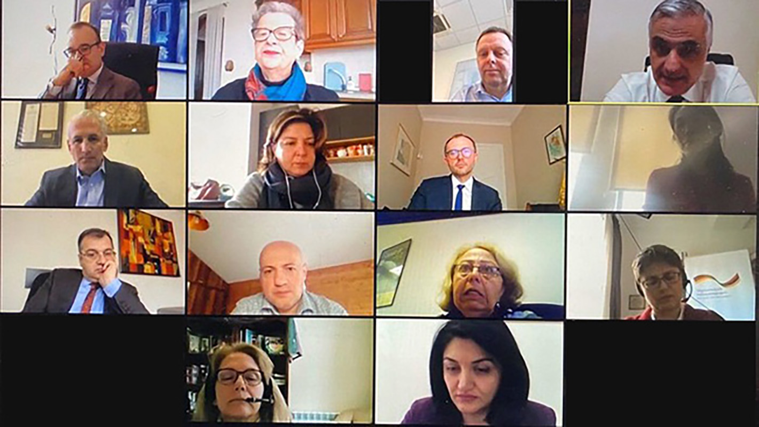
On 31 March, by the initiative of the Deputy Prime Minister of Armenia, Mher Grigoryan, and the UN Resident Coordinator in Armenia, Shombi Sharp, a video conference took place with the participation of Commandant's Office, the Ministry of Health, the Ministry of Foreign Affairs and the representatives of the development partners of Armenia - international financial organizations, development agencies and diplomatic missions in Armenia.
During the video-conference, the Deputy Prime Minister, Mher Grigoryan presented, to the international partners the measures initiated by the Government to mitigate the economic impact of the new coronavirus and proposed to combine efforts to make them more efficient and targeted.
The UN Resident Coordinator in Armenia, Shombi Sharp presented the coordination of the international partners’ work and emphasized their commitment to continue supporting the efforts of the Government of Armenia to prevent the spread of the coronavirus.
During the discussion, the Deputy Minister of Health, Lena Nanushyan, presented to the partners the anti-epidemic measures implemented by the Government.
A number of international partners presented their tools and quick response plans for the current situation.
At the end of the meeting, on behalf of himself and the Government, the Deputy Prime Minister, Mher Grigoryan, thanked the international partners for their support during this important times.

