FAO provides emergency assistance to conflict affected people in Armenia

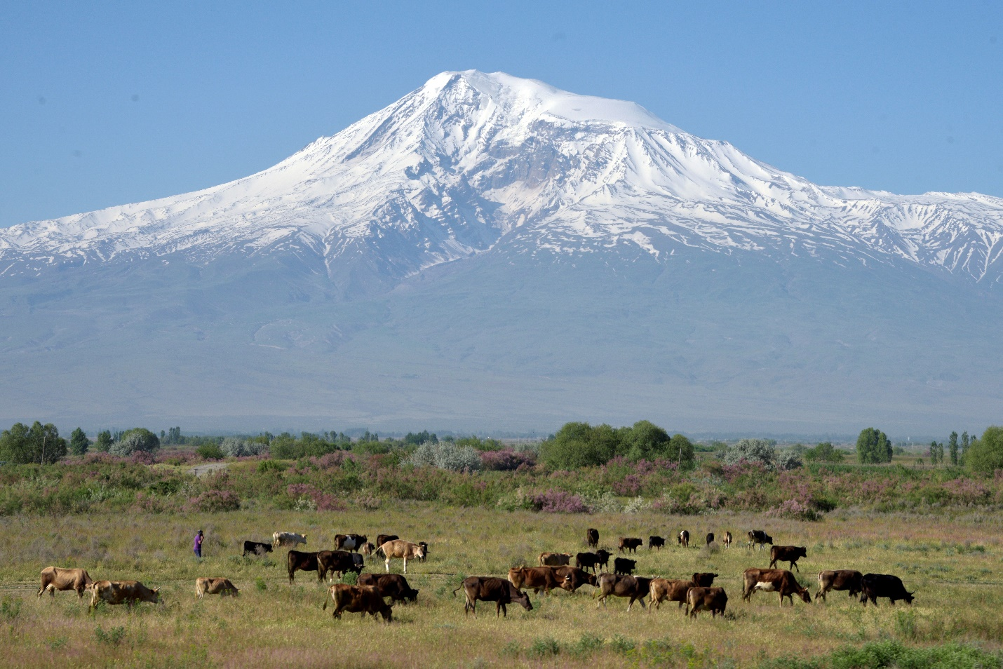Photo: Ararat valley, Armenia, ©FAO/Karen Minasyan

25 January 2021, Yerevan, Armenia – The Food and Agriculture Organization of UN (FAO) has launched an emergency assistance project to help the Nagorno-Karabakh conflict affected vulnerable groups in Armenia. The project will be implemented in collaboration with the Ministry of Economy of Armenia, and the Food Safety Inspection Body aiming to provide very rapid response to cover critical gaps in support to Government’s interventions, through provision of agricultural inputs such as feed for animals, equipment and materials for building temporary shelter for displaced farming livestock.
“The project will be important to allow rapid response, but more support is needed for the upcoming agricultural season.” said Raimund Jehle, FAO representative in Armenia.
Following the conflict related to Nagorno-Karabakh (NK) it is estimated that 12 000 to 55 000 cows and between 60 000 and 90 000 small ruminants have been moved to Armenia by displaced families.

