**Alphonso Davies becomes the first footballer to take UNHCR’s Goodwill Ambassador title**

Davies is the first footballer and first Canadian to become a Global Goodwill Ambassador for UNHCR

24 March 2021

[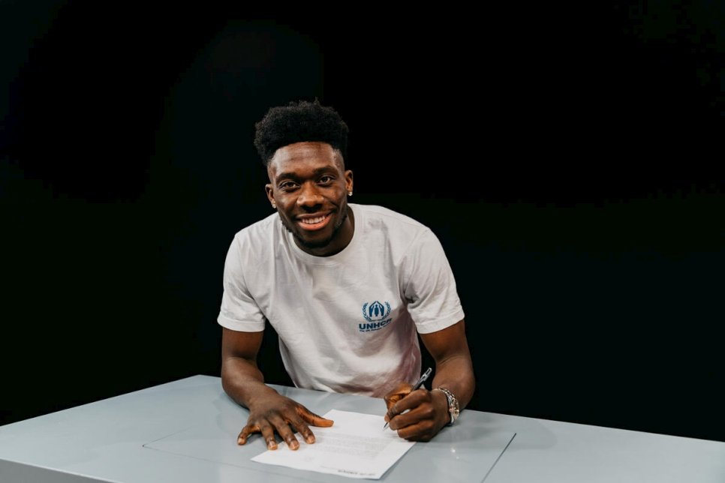](https://www.unhcr.org/X75)

*Alphonso Davies signs Goodwill Ambassador agreement with UNHCR at FC Bayern Munich’s training ground.  © UNHCR/Marco Donato*

UNHCR, the UN Refugee Agency, today announced the appointment of Alphonso Davies, FC Bayern Munich’s left-back and player for Canada Men’s National Football Team, as its newest Global Goodwill Ambassador.

Accepting his new role as UNHCR Goodwill Ambassador, Davies said: “I am proud to join the UN Refugee Agency, as a Goodwill Ambassador. My own experiences make me want to speak up for refugees, to share their stories and to help make a difference.”

Welcoming Davies on UNHCR’s Goodwill Ambassador team, Filippo Grandi, the United Nations High Commissioner for Refugees, said: “Alphonso Davies personifies the power of sport and we are truly honored to have him joining us. Sport has the incredible power to bring hope, to heal and to help shape the future for those forced to flee. In our work with refugees we see daily what uplifting difference sports can make in their lives.

“His personal story, his talent and triumph as a professional footballer and his commitment to help refugees is impressive. I am looking forward to working with him.”

Born in a refugee camp in Ghana, to Liberian parents who fled the civil war in their home country, Davies knows first-hand what it means to be a refugee: “Whilst the refugee camp provided a safe place for my family when they fled war, I often wonder where I would have been if I had stayed there and not benefited from the opportunities I got thanks to resettlement. I don’t think I would have made it to where I am today.”

Davies and his family were resettled to Canada when he was five. At 15, Davies began playing professional football and only a year later he had his national team debut, making him the youngest player ever on Canada’s Men’s National Team. Now at 20, Alphonso is keen to support the work of UNHCR and harness the power of sport to help those forced to flee to build a better future:

“I want people to know about the importance of helping refugees, wherever they are, in camps or cities, in neighboring countries or countries of resettlement such as Canada. Refugees need our support to survive, but also access to education and sports, so they can fulfil their potential and truly thrive.”

Alphonso Davies started supporting UNHCR in 2020, including through a [livestream tournament for refugees](https://www.unhcr.org/news/press/2020/4/5e9ee5d34/asmir-begovic-alphonso-davies-compete-online-aid-coronavirus-response.html). In February 2021, Davies helped launch a Canadian Government campaign, called [Together for Learning](https://www.canada.ca/en/global-affairs/news/2021/02/canada-launches-global-campaign-to-address-education-crisis-for-refugees-and-internally-displaced-children-and-youth.html), to promote access to quality education for refugees around the world.

Davies is widely considered as one of the best left-backs in the world due to the combination of his explosive pace and vision. In 2020, he was named Bundesliga Rookie of the Season and was part of the FC Bayern Munich team winning six prestigious titles.