place
Yerevan

date
24 June 2021
UNHCR News
Tel. +41 22 739 85 02
www.unhcr.org
@RefugeesMedia
@Refugees
Global Media Contacts
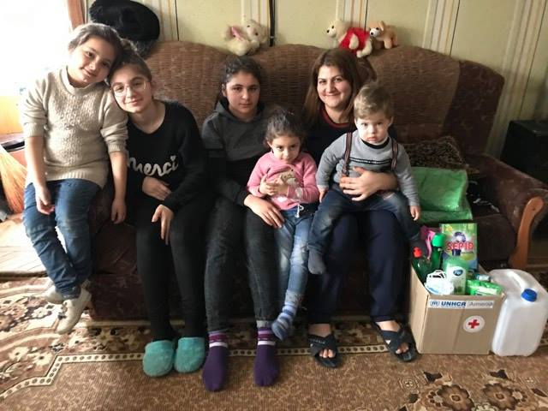
Owing to the generous contribution by the US Government, families displaced from Nagorno-Karabakh to Armenia benefit from UNHCR’s humanitarian assistance distributed through its partner NGOs, Armenian Red Cross Society and Mission Armenia.
December 2020. Hrazdan, Kotayk Province, Armenia. © UNHCR/Anahit Hayrapetyan

UNHCR Welcomes the U.S. Support for Refugees and Asylum-Seekers in Armenia

ARMENIA

UNHCR, the United Nations Refugee Agency, welcomes the recent contribution from the Government of the United States of America (USA) to provide essential humanitarian assistance to refugees and asylum-seekers in Armenia.

With the continued support from of the U.S. Bureau for Population, Refugees and Migration (PRM), UNHCR has been able to deliver vital emergency assistance to persons in a refugee-like situation affected by the Nagorno-Karabakh conflict, as well as to refugees and asylum-seekers residing in Armenia whose livelihoods have been negatively affected by the COVID-19 pandemic. U.S. funding towards UNHCR’s programme will also contribute to providing and achieving solutions for the most vulnerable refugee families and children, including in protection, education, and strengthened community empowerment.

“We are pleased to work with UNHCR Armenia as it executes its critical mission of supporting those in need. The challenges of the past year remind us anew of the great importance of UNHCR’s work,” said U.S. Ambassador to Armenia Lynne M. Tracy. “The United States is proud to partner with the UNHCR and our Armenian counterparts to help improve the lives of those negatively affected by the intensive fighting over Nagorno-Karabakh and the turbulence of the COVID-19 pandemic.”
The United States’ support in the form of flexible funding is critical to UNHCR as it enables the organization to determine how best to protect and assist those who are in the greatest need or at the greatest risk quickly and effectively.

“UNHCR would like to thank the people and the Government of the United States for their enduring commitment and support for vulnerable and displaced populations in Armenia” said Anna-Carin Ost, UNHCR Representative in Yerevan. “This contribution is crucial as with it we are able to help refugees and people living in a refugee-like situation in Armenia, including those displaced from Nagorno-Karabakh. With US support, UNHCR has been able to respond to the needs of vulnerable displaced people, providing winter clothes to families amid freezing winter conditions, hygiene kits, bedding sets, and household items; and repairing collective shelters.”

UNHCR is grateful for the generous and long-standing support of the United States, which allows UNHCR to continue to provide protection, legal support, and pursue durable solutions for refugees, stateless persons, and those living in a refugee-like situation throughout the country.

FOR MORE INFORMATION PLEASE CONTACT:
Mr. Russell Fraser
External Relations Officer, UNHCR Armenia
fraser@unhcr.org

